Chapter 5, Solution 4.

v₀ = Av_{d} = A(v₂ - v₁)
v₂ - v₁ = 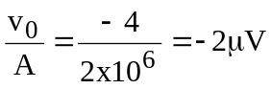

v₂ - v₁ = -2 µV = –0.002 mV
1 mV - v₁ = -0.002 mV
v₁ = 1.002 mV

